ASSIGNMENT 2

SUBMITTED BY : NITIN KUMAR DATE:27/03/2023

STEP 1 FIRST WE HAVE TO CREATE PROJECT IN SCRUM

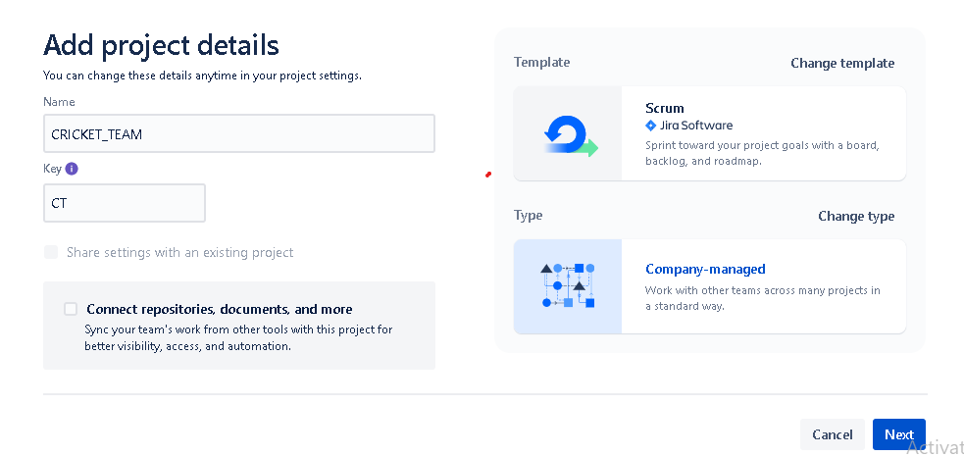

STEP 2: THEN WE HAVE TO CREATE COMPONENTS

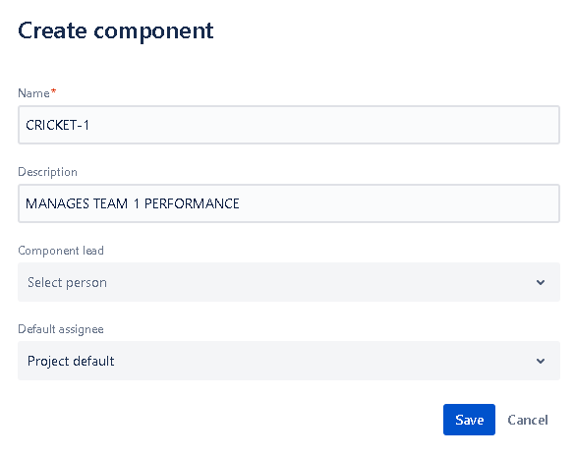

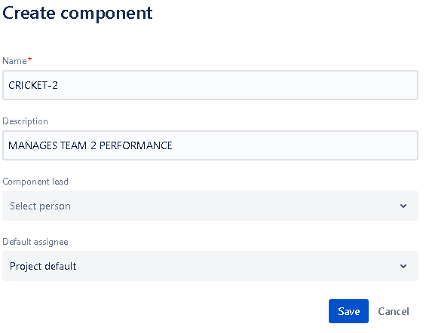

STEP 2: THEN WE HAVE TO CREATE VERSIONS

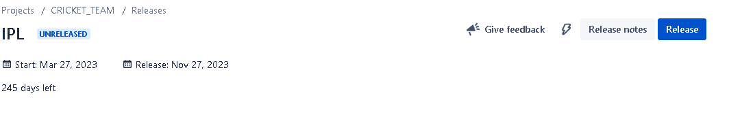STEP 3: THEN WE HAVE TO CREATE EPIC

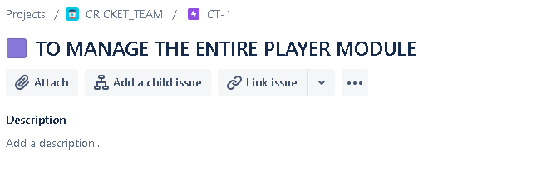 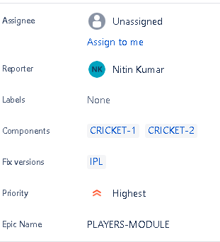

WE HAVE TO CREATE SPRINT AND BACKLOG FIRST

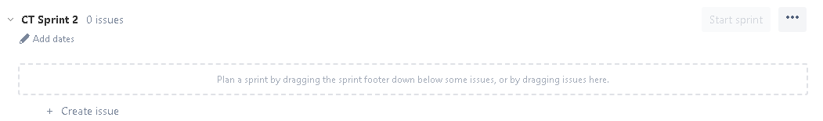 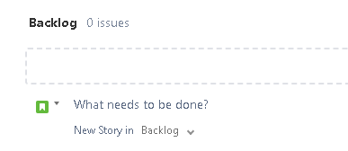

STEP 4: THEN WE HAVE TO CREATE STORY

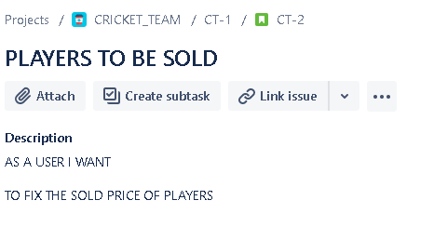

GIVE STORY POINTS

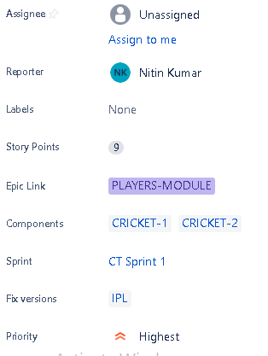

STEP 5: THEN WE HAVE TO CREATE 2 SUBTASKS

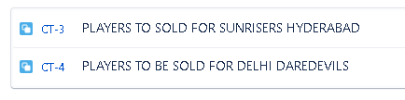

SUBTASK 1 DETAILS WE GIVE ORIGINAL ESTIMATE TO SUBTASK

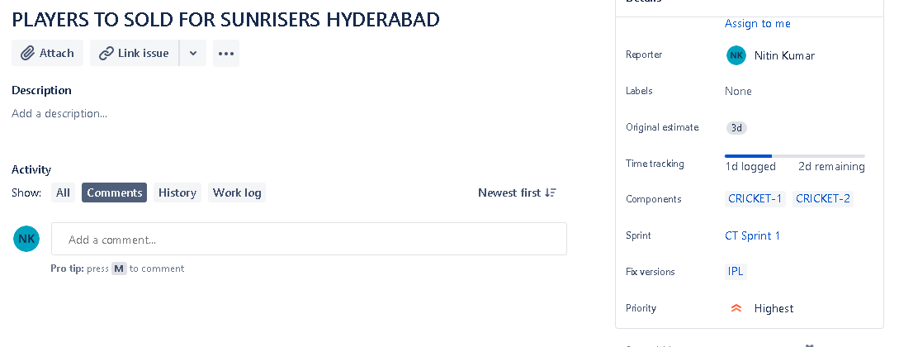

SUBTASK 2

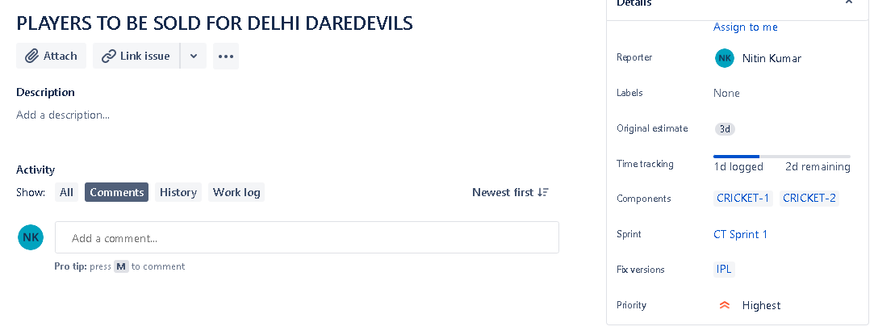

STEP6 THEN WE HAVE TO CREATE BUG

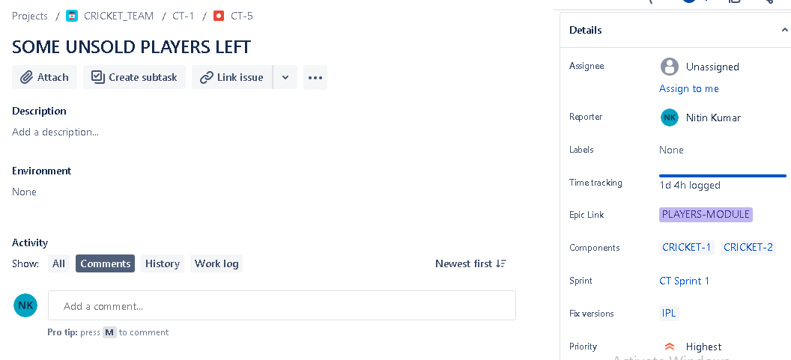

STEP7 THEN AFTER CTREATING MODULE WE HAVE TO START SPRINT

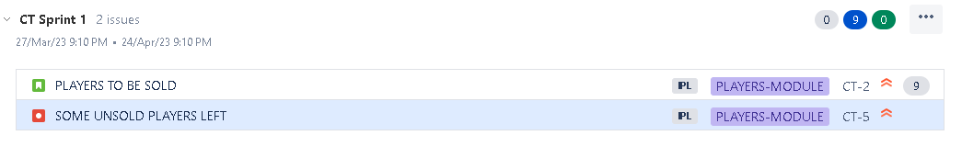

THEN WE HAVE TO START SPRINT

